**Name: STEBIN BABU**

**Roll No:44**

**Batch:B**

**Date:03/04/2022**

**NETWORKING & SYSTEM ADMINISTRATION LAB**

**Experiment No.: 2**

**Aim**

Familiarization of Hardware Components in a Computer.

**Procedure**

### ****Mouse****



A mouse is a hardware input device that is used to move the cursor or pointer on computer screens.It can also be used to run computer programs, select items in a graphical user interface, and manipulate objects in the computer world.Some common examples of how it can be used are clicking on buttons, scrolling up and down the screen, selecting files, opening folders, and so on

### ****2.Motherboard****



The motherboard is the backbone of our computer system. It's the central processing unit or CPU.It connects all the other components, like memory and graphics card, to the power supply.  
The motherboard is where all the wires are plugged in and it's also where you place your RAM, which is your computer's working memory.The motherboard is what makes one machine different from another.Motherboards are made up of tiny transistors that control the flow of electricity through copper tracks on their surface.These transistors are called Integrated Circuits or ICs for short.

### ****3.CPU ( Central Processing Unit )****



The central processing unit, or CPU for short, is responsible for processing all information from programs run by your computer. Each CPU has a clock speed, which is the number of instructions it can process in any given second, measured in gigahertz. The quality of a computer's CPU has a major effect on overall system performance.

### ****4. RAM Memory****



Random Access Memory (RAM) is the physical hardware inside a computer that temporarily stores data. It is normally found in the memory slots of the motherboard. Its role is to serve as the computer's "working memory" for the information created by programs.Generally speaking, the faster the RAM, the faster the processing speed at which memory moves data to other components.

### ****5.ROM Memory****

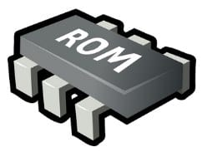

ROM stands for a type of memory chip that can be read from but not written to.In other words, it's a form of data storage that can't be changed after being programmed.It's sometimes called "non-volatile" memory because the stored information will remain even when not powered up or in use.ROM is often used to store a computer's basic start-up instructions and certain types of data, such as your car's onboard computer system and a calculator's data tables.

### ****6. Hard Disk Drive****



A hard disk drive is a piece of hardware inside a computer that stores information.It's used to store software and data in a safe place, which can be accessed when needed.With magnetic storage, there are no moving parts - unlike a CD or DVD player in which you need to move a disk in order to access data.You can think of it as "a closet" where all your stuff is stored safely.As long as you have power, you can get to your things when you need them.

### ****7.Optical Drive****



Optical Drives are used in PCs to read and write CDs and DVDs.The optical drive reads the data from the disc, which can then be transformed into a digital file that is readable by the computer.This makes it easy to backup files, play music or movies, or copy data from one disc to another.The term "CD" refers to Compact Discs, which are the most common type of optical drive on modern computers.They are often used for installing software on your computer, moving data between computers, or writing new programs.

### ****8**.**Power Supply****



A power supply is an electrical appliance that provides the necessary power to operate a computer.Computers are powered by electricity, and the power supply converts the alternating current (AC) from the electric outlet into direct current (DC).The power supply in a computer can be an internal or external component.It’s important to make sure your power supply is functioning properly.

### ****9.Sound Card****

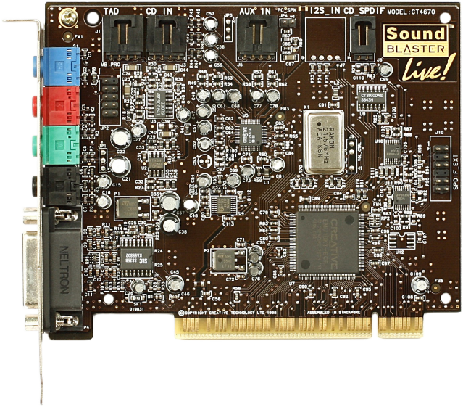

A sound card is a computer chip that processes and amplifies sounds.It produces a signal to the speakers, headphones, or other output devices.The sound card can also be called a "sound card" or "audio card."Computers with sound cards are capable of playing digital music files and videos, as well as speech synthesis.Sound cards were originally provided as an external device for home computers in the 1980s.With the development of microprocessors, sound capabilities were integrated onto motherboards during the 1990s.

.

### ****10.Keyboard****

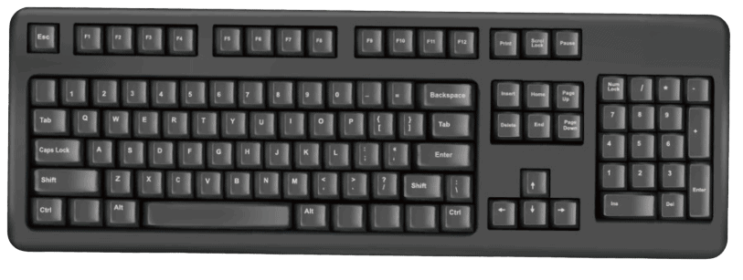

A keyboard is an input device that you use to enter data into a computer.It's also called the input device for your computer. Keyboards are used with PCs, laptops, tablets, and other devices.There are many different types of keyboards, but the most common one is the QWERTY keyboard.A QWERTY keyboard has all the letters in alphabetical order on it.This is different from some other types of keyboards, like Dvorak or Colemak keyboards.For example, these keyboards have keys arranged differently than what you’re used to seeing on a QWERTY keyboard.And that means that typing on these keyboards will feel like typing in another language at first! But don’t worry - once you get accustomed to it, it feels natural!